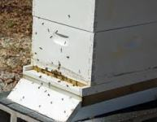 | 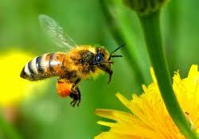 | 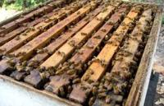
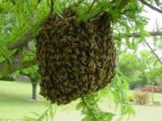 | 8th Annual  North  Alabama  Beekeepers  Symposium  August 18,  2018  Presented By:  Limestone County  Beekeepers Association  WWW.LCBEES.COM  LCBEES.AL@gmail.com | 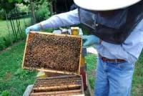
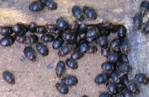 |  | 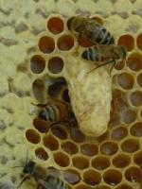
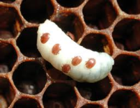 | 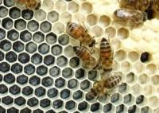 | 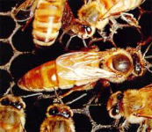
Symposium site:
Friendship United Methodist Church
16479 Lucas Ferry Rd
Athens, AL. 35611
.

Program

8:00 - 8:30 | Registration and Refreshments
8:30 - 8:45 | Welcome - Mr. Lionel Evans
8:45-9:15 | Dr. Jim Tew— Taking a Sting with Dignity
9:15-9:25 | Break
9:25-10:25 | Session 1
Room | Speaker | Subject
A | Dr. Clarence Collison | Applying The Basics Of Honey Bee Biology
B | Mr. Randy Hamann | Monitoring Africanized Honey Bee Activity
C | Mr. Phillip Garrison | Getting into Beekeeping: For Beginners
D | Mr. Bill Mullins | Queen Rearing - Jenter System
E | Mr. John Mynard | Honey Bee Nutrition: Needs and Supplements
10:25-10:40 | Break
10:40-11:40 | Session 2
A | Dr. Jim Tew | Making Hard Decisions About Honey Bee Queens
B | Mr. Randy Hamann | Monitoring Africanized Honey Bee Activity
C | Mr. Bob Fanning & Glen Craiger | Beginning Beekeeping: 1st Year Progressive 1
D | Mr. Wil Montgomery | Queen Rearing—Cell Punch Method
E | Mr. Wes Caudle | Location and Setup of Your New Apiary
F | Mr. Todd Mullins | How, When, and Why to Feed bees
11:40-1:00 | Lunch and Door Prizes
1:00 – 2:00 | Session 3
A | Dr. Clarence Collison | Honey Bee Mating Biology
B | Mr. Lonnie Funderburg | Floral Sources of Pollen and Nectar
C | Mr. Bob Fanning & Glen Craiger | Beginning Beekeeping: 1st Year Progressive 2
D | Mr. Bill Mullins | Queen Rearing - Jenter System
E | Mr. Phillip Garrison | Harvesting Your Honey Crop
F | Mrs. Bonnie Funderburg | Lotion Bars
2:00-2:15 | Break
2:15- 3:15 | Session 4
A | Dr. Clarence Collison | The Importance Of Quality Queens
B | Dr. Jim Tew | The Dancing Bees. An Impossible Achievement
C | Mr. Bob Fanning & Glen Craiger | Beginning Beekeeping: 1st Year progressive 3
D | Mr. Todd Mullins | When and How to feed Bees
E | Mr. John Mynard | Checking For Diseases-What To Look For?

3:15-3:30 | Break
3:30-4:30 | Session 5
A | Dr. Jim Tew |  | “Our Present Environment—How Big A Problem is it for our Bees?”
B | Mr. Lonnie Funderburg |  | Floral Sources of Pollen and Nectar
C | Mr. Bob Fanning & Glen Craiger |  | Beginning Beekeeping 1st Year Progressive 4
D | Mr. Wil Montgomery |  | Queen Rearing – Cell Punch Method
E | Mr. Wes Caudle |  | Location & Setup of your New Apiary
4:30 | Closing Remarks and Evaluations in Main Auditorium
Open Hive Demonstration (Weather permitting) Will Be Held From 2:15 Til 3:15
Speakers
Dr. Jim Tew |  | Beekeeping Specialist, Alabama Cooperative Extension System, Auburn University and Professor Emeritus Ohio State University. Since 1975, Jim has taught classes, provided extension services, and conducted research on honey bees and honey bee behavior - specifically pollination behavior.
Dr Clarence Collison |  | Beekeeping Specialist, Emeritus Professor/Dept. Head, Dept. of Entomology And plant Pathology,  Mississippi State University.
Philip Garrison |  | Past President Alabama Beekeepers Assn., President, Cullman County Beekeepers Assn
Lonnie Funderburg  Bonnie Funderburg |  | Past President Alabama Beekeepers Assn. President, Walker County Beekeepers Assn.  Member and Treasurer Alabama Beekeepers Assn.
Bill Mullins |  | Queen Breeder, Member Madison County & Limestone County Beekeepers Assn
Bob Fanning |  | Past President Alabama Beekeepers Assn.. Assisted by Glen Craiger, Madison Co. Beekeepers Assn.
Wil Montgomery |  | Member Alabama Beekeepers Association
Randy Hamann |  | Alabama State Apiarist, Southern Division
Todd Mullins |  | Member Limestone & Madison Co Beekeepers & Alabama Beekeepers Assn.
Lionel Evans |  | Limestone County Beekeepers Assn. Member Madison County & Ala. Beekeepers Assn.
John Mynard |  | Retired, Alabama State Apiarist, Northern Division, active, Central State of Alabama Apiarist
Wes Caudle |  | Alabama Dept. of Agriculture and Industries, State Apiarist Northern District
Glen Craiger |  | Madison County Beekeepers & Limestone County Beekeepers Assn.

The Limestone County Beekeepers Association would like to give a special thanks to
Friendship United Methodist Church for allowing the use of this great facility to assist us
in the education of fellow and future beekeepers.
Also, Thanks to the following vendors for being here, and their donations.
Kelley Beekeeping Company  PO Box 240  Clarkson, KY 42726.  https://kelleybees.com/  800-233-2899 or 270-242-2012 | Dadant & Sons Inc.  51 South 2nd  Hamilton, IL 62341  http://www.dadant.com/  888-922-1293
Rossman Apiaries Inc.  P. O. Box 909  Moultrie, Georgia 31776-0909  http://www.gabees.com/  800-333-7677 | Friendship United Methodist Church  16479Lucas Ferry Road  Athens, AL. 35611
Our open hive demonstration will be conducted behind the house  of Faye C. Baker  17690 West Washington St.  The map to the right is the directions from Friendship United Methodist Church to the bee yard. | 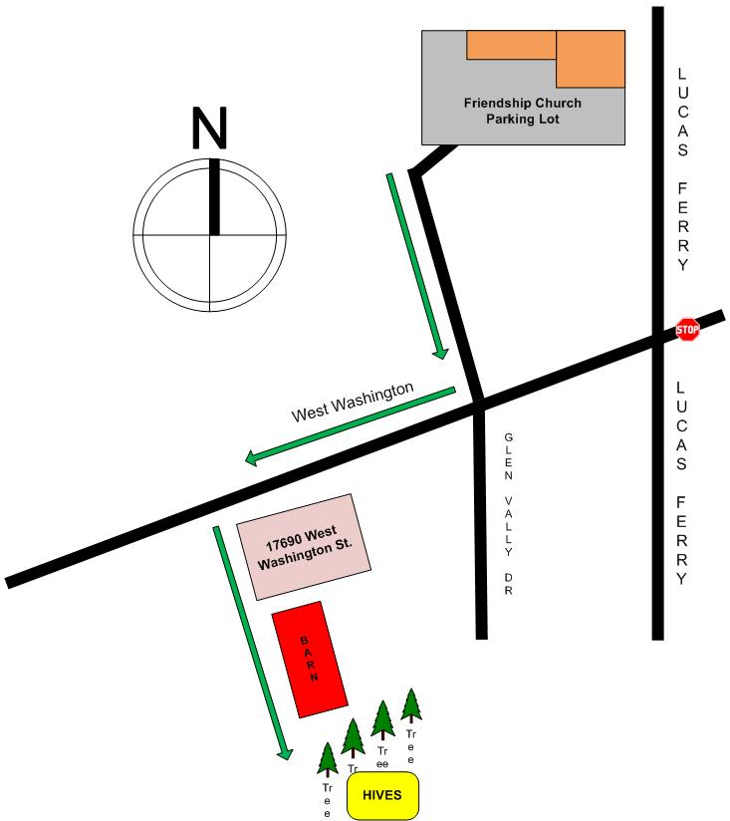
Friendship United Methodist  Classroom Locations and Emergency Exits | 